7001NATSCI Advanced Osteology and Skeletal Pathology

Academic Year: 2018-2019

Report on Skeleton LJMU-43

Remain number I guess

Cobi Gottschalk

Student I.D.# 833759

Word Count- 2,600

December 17, 2018

**7101NATSCI Advanced Osteology & Skeletal Pathology**

**Skeletal report summary form**

|  |  |
| --- | --- |
| **Recorded by** | Cobi Gottschalk |
| **Date** | 12/12/2018 |
| **Skeleton number** | POU-229 |
| **Age** | 7 ± 2 |
| **Sex** | Inconclusive |
| **Stature** | Inconclusive |
| **Preservation** | Good condition. Most bones are fully preserved with minimal postmortem damage. |
| **Pathological conditions** | Possible periodontal disease. |

**General Information**

I arrived to room BS452 in James Parsons Tower at 9:00 am Wednesday 12th 2018 to begin my examination of the skeletal remains. I was assigned to the skeleton POU-229 and finished my examination at 5:00 pm Wednesday 12th 2018. The remains were retrieved through an archaeological excavation and the individuals are from the medieval period. Throughout the duration of the exam, I removed the skeletal remains that were sealed within several bags, and placed them into anatomical position. I then made a skeletal inventory of the remains present and began to document any signs postmortem trauma, pathology, soil erosion, etc. Photographs were taken using an 8 megapixel camera with 1.5µ size pixels and scales were used for size.

**Purpose**

The purpose of this report is to establish a biological profile of the individual and to note the condition of the remains. This includes documenting any signs of pathology, staining, soil erosion, postmortem fractures, root damage, etc.

**Condition of Remains comments on trends (erosion,staining, postmortem fractures, excavation damage, root damage, etc)**

The skeletal remains were in relatively good condition overall. The upper and lower limbs were fully preserved and many of the epiphyses were present. I could detect no signs of delamination or warping on any parts of the skeletal remains. There also does not appear to be any signs of animal scavenging or damage from root activity due to the absence of puncture marks and lack of root etching.

The whole mandible is present but the left lateral side is broken off from the rest of the bone right before the medial side of the permanent first lower left molar. The alveolar bone of the right and left maxillary bones appears receded in certain areas which has left the roots of some teeth exposed. There are signs of mixed dentition with multiple teeth still inside the alveolar bone. There are also three loose teeth, two of which have no roots and show signs of dental wear.

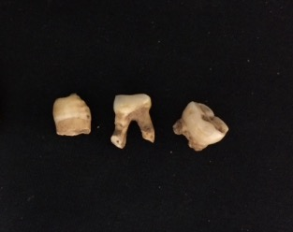

Figure 1. Three deciduous loose teeth with two showing signs of occlusal wear and no roots (lost postmortem).

The right femur was broken in the middle of the diaphysis at the center of the bone. This type of fracture is characteristic of a transverse fracture because of the horizontal breakage of the bone. This does not appear to be any sort of antemortem trauma because there is no sign of healing and the color remains consistent with the rest of the bone. If this fracture were to happen when the individual was alive the femur would have gone through certain stages of repair. First there would be the formation of a fracture hematoma and later an internal and external callus would start to form. After this, the cartilage of the external callus would be replaced with the formation of new bone. These events occur early on in the repair process such as two to three weeks. The distal end also has a brownish stain on the anterior side which is typical of soil staining.

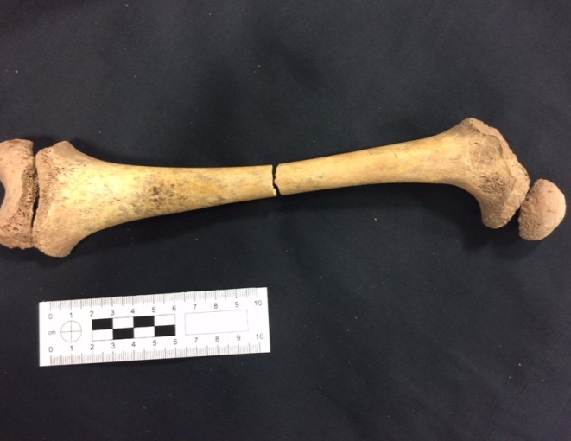

Figure 2. Right femur with epiphyses and a transverse fracture that occurred postmortem.

The skull was the most heavily fragmented part of the skeleton. The bones of the cranium such as the parietals, temporals, and occipital had the most fragmentation all of which occurred postmortem. Certain features allowed for the fragmentary pieces of bone to be identified such as the preservation of the petrous pyramid of the right and left temporal, the supraorbital ridge of the frontal bone, etc. On the fragmented pieces of occipital bone, there is this green brownish stain that can possibly be the result of soil staining or algae staining. I do not believe this is a result of metal staining because the color does not exhibit a copper coin like appearance.

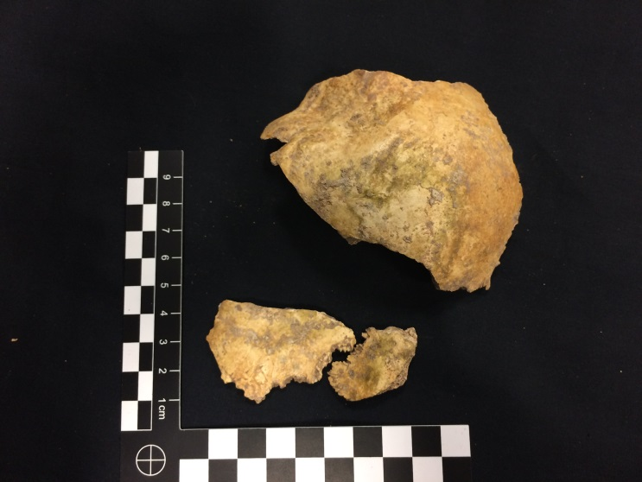

Figure 3. Fragmentary pieces of the occipital bone which has a greenish brown stain, likely a result from algae or soil staining.

The right and left scapula both have a small portion of the subscapular fossa missing. This feature is very thin which makes is very susceptible to postmortem trauma. Also, the inferior angle of the right scapula is broken off from the rest of the bone.

The whole vertebral column is present and in relatively good condition. The anterior arch of the first cervical vertebra Atlas is broken off but is still well preserved. Some of the other cervical vertebrae have parts of the transverse foramen missing but for the most part are entirely intact. The same is true for the other twelve thoracic and five lumbar vertebrae. Also, there is a lot of porosity on many of the vertebrae as well as the segments of the sacrum.

All of the ribs for the right and left side are almost completely preserved with only a few fragments missing.

**Inventory**

Skull

Occipital- Fragmented, possible soil staining

Right and Left Parietal- Fragmented

Right and Left Temporal- Fragmented

Frontal- Fragmented

Right and Left Maxilla and Dentition- 11,12,13,16,17,21,26,27,54,55,54,65

Mandible and Dentition- 31,32,36,37,41,42,43,44,46,47

Loose Teeth (3)- Canine (No root), Molar (No root/Dental wear), 74

Arms

Right and Left Scapula

Right and Left Clavicle

Right and Left Humerus-

Right and Left Ulna

Right and Left Radius

1 Right Carpal- Possibly Triquetral

5 Right and 5 Left Metacarpals

5 Right and 4 Left Proximal Hand Phalanges

1 Right and 3 Left Intermediate Hand Phalanges             Come back to these

7 Cervical Vertebrae

12 Thoracic Vertebrae

5 Lumbar Vertebrae

Ribs

12 Right and 12 Left Ribs

Pelvic Girdle

4 Sacral Vertebrae- Unfused

Right and Left Ilium

Right and Left Ischium

Right and Left Pubis

Legs

Right and Left Femur- Transverse fracture on right femur

Right and Left Tibia- Proximal and Distal Epiphyses

Right and Left Fibula- Proximal Epiphyses

Feet

Right and Left Calcaneus

Right and Left Talus, 2 Other Right Tarsals (Possibly Medial and Later Cuneiform)

5 Right and 5 Left Metatarsals

3 Right Proximal Foot Phalanges

1 Right Distal Foot Phalaynx

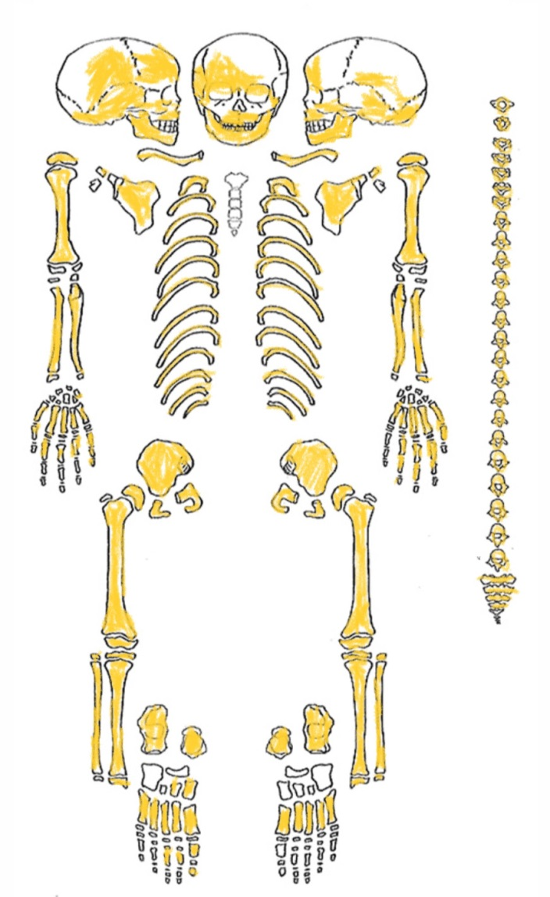

Figure 1. Skeletal Diagram of specimen POU-229. Bones that are present are highlighted in yellow.

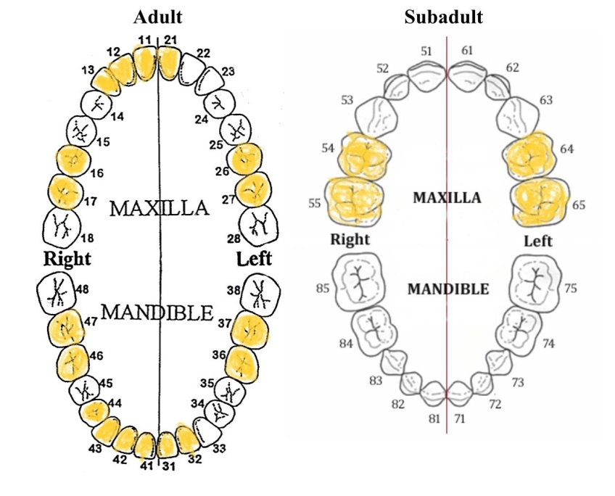

Figure 2. Dental diagram of specimen POU-229. Teeth highlighted in yellow represent dentition that is fully erupt as well as those that are still inside the alveolar bone. Three loose teeth are not shown here, but are mentioned in the inventory.

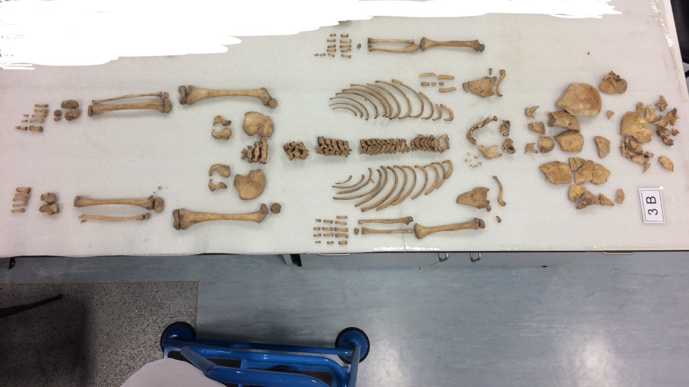

Figure 5. Photograph of specimen POU-229 in anatomical position.

**MNI**

There are no repeating bones so the minimum number of individuals is one because of the lack of skeletal overlap. Also, there does not to appear to be any evidence here that would suggest there was commingling of remains.

**Age**

Using Ubelaker’s (1989) data on dental development, it appears that this individual has an age at death of around seven years old plus or minus two years. I also used five eruption categories to describe individual teeth to document the stage of development (Ewbank et al., 1964). A tooth receives a score of zero if it has not yet erupted and a one if it is visible in the alveolar process. If it is visible in the alveolar bone its receives a score of two and a score of three if it is half erupted. If it is fully erupt with minimal or no wear, it is scored a four. A score of five means the tooth is erupt and in wear.

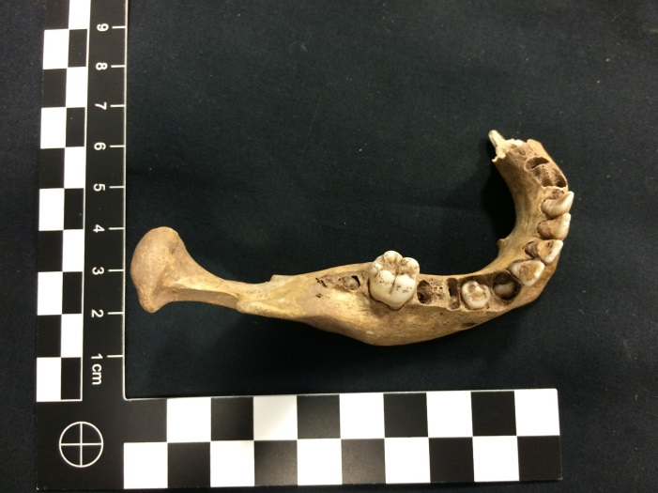

Figure 3. Occlusal view of dentition from the mandible.

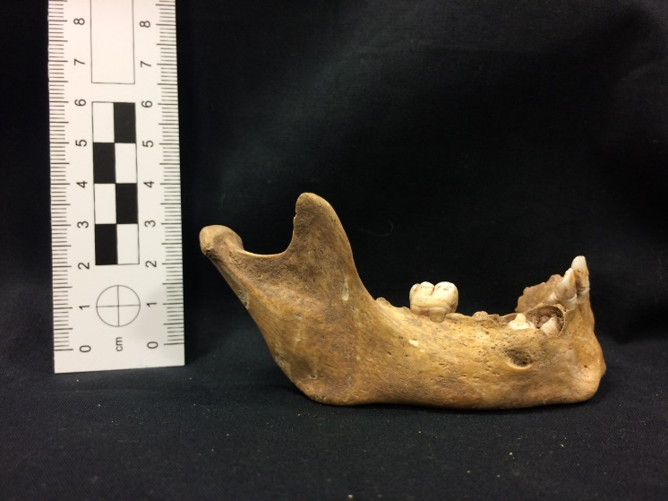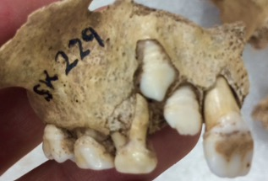

Figure 5. Lateral view of right maxilla showing mixed dentition and developmental stage of the teeth.

Figure 4. Lateral view of right portion of mandible showing permanent dentition that has not yet emerged.

Looking at the mandible, there are spaces where deciduous teeth were once present and are mixed with permanent teeth that have not yet begun to emerge. The permanent upper right canine that is visible in the maxillary bone is categorized as a zero in development. This is because while it can be seen due to fragmentation of the right maxilla, it would still not be visible from an occlusal view of the alveolar process. The permanent lateral incisor on the right maxilla is at a one in the developmental stage due to its visibility in the alveolar process. The lack of a deciduous upper right lateral incisor suggests that the individual is around the age of seven since this is about the age when that tooth begins to shed. Also, through combining this evidence with the dentition that is present on the mandible, it only further substantiates this age estimate. In addition to using Ubelakers (1989) data, I cross referenced it with AlQahtani’s research on the developmental stages for teeth when determining the age of this individual.

The first permanent right molar is at a four in development and this occurs around the age of seven years old (AlQahtani et al., 2010). Also, because the lower right canine and lower right first premolar are at a zero in development, it shows that the individual cannot be older than ten and half years of age.   
  
While examining the dentition of juveniles is a reliable aging method, I also used fusion for certain elements of the skeleton as a means of narrowing the age estimation for this individual.

The special vertebrae of the sacrum have not fused together further supporting that the age of this individual is very young. There are four segments of the sacrum present, all of which are in good condition. By age six or seven, there are five segments of the sacrum that are unfused. Between the ages of seven and fifteen the spinous process starts to fuse through the continuation of growth by the laminae (Baker et al., 2005). Both of the auricular surfaces on the illiums are fully preserved but there are no non metric methods that can be used on them for age estimation with juveniles. Lovejoys system in which each age range is placed into a certain phase of development starts with phase one covering ages twenty to twenty-four (Lovejoy et al., 1985b). The same is true of the Suchey-Brooks method even though their phase one covers ages fifteen to twenty-five (Brooks and Suchey, 1990). While it is not possible to estimate the age from the auricular surface on this individual, certain age ranges can be eliminated through examining developmental stages in ossification. Because the ilium, ischium, and pubic bone are unfused, it is known that this individual has not yet reached the age of fourteen or seventeen. This is because the ilium fuses with the other two bones at the acetabulum between the ages of eleven to fifteen in females and fifteen to seventeen in males (Baker et al., 2005).

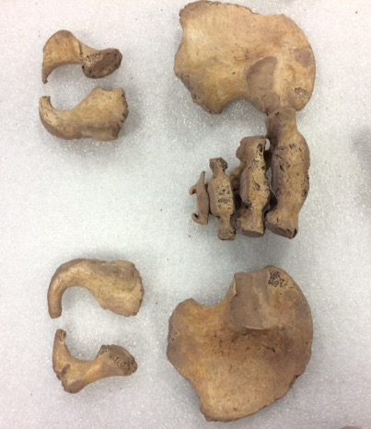

Figure 6. Anterior view of the unfused bones of the pelvic girdle.

The same process of elimination can be done when looking at the unfused femoral head of the left and right femora. The head of the femur fuses to the rest of the bone between the age range of eleven to sixteen years in females and between the age range of fourteen to nineteen years in males (Hansman, 1962)(Juv Skel Book351).

Therefore, with these known age ranges of fusion for particular bones of the human skeleton, the estimated age can be lowered to below eleven years old for this individual.

**Sex**

The sex remains inconclusive because of the age of the individual. It is not possible to look at sexually dimorphic traits that can be found on the skeleton when dealing with juveniles especially with the age of this individual. While the illium, ischium, pubis, and sacrum are present they are not fully fused which would allow us to look at certain sexually dimorphic features such as the subpubic angle and shape of the pelvic outlet that can be found in older individuals.

A metric-measurement method that estimates sex based on the maximum femoral diameter cannot be performed on this individual because the epiphyses of the proximal femora are not fused to the rest of the bone (Pearson 1917-19, cited in Bass, 2005). Also, because of the individuals age, the head of the femur has not reached the maturity required take the measurements.

Sexing juveniles, especially in adolescent years, is difficult because of the different rates and times in which males and females mature. There is already a wide amount of variability in growth within individuals of the same sex. Therefore, any quantitative measurements would be of little to no use when estimating the sex of a juvenile skeleton. This makes determining the sex of an immature skeleton, undoubtedly one of the biggest problems when it comes to sexing juveniles (Scheuer and Black, 2004).

The mental eminence of the mandible can be useful when determining the sex of an unknown adult skeleton. In Buickstra and Ubelakers Standards book (1994), they provide a scoring system from one to five that categorizes the amount of projection that is being emitted from the area. Little to no projection is indicative of female and prominent expression is more characteristic of males.  While there is the presence of a mandible from this individual, it is not sufficient enough to come to a determination on this particular skeleton. For the same reasons mentioned previously about amount of variability in early developmental growth between males and females, it would not be useful to examine for sex estimation when the bone is still in the process of maturing.

In a study done by Molleson et al. (1998), they found that the mandibular angle and shape of the chin could be useful when determining the sex of juveniles. However, they indicated that this method would have to be tested on a larger sample of juveniles with a known sex.

**Ancestry**

The ancestry remains inconclusive due to the age of this individual. Estimating ancestry in adults is difficult and in young juveniles it is basically impossible as there is very little information on the matter to make a determination ( Sheuer and Black, 2004). Typically in adult skeletons,

there are certain features of the skull that can be examined such as the width of the nasal aperture, the angle and shape of the orbits, the amount of projection from the cheek bones, etc. (Hefner, 2009) (powerpoint). Because juveniles are in the process of maturation, many of these features listed are still going through morphological changes. Therefore, trying to examine these characteristics with this particular individual would not be able to give any clear indication of ancestral background.

**Stature**

When estimating the stature of an individual, the maximum length of long bones can be measured to get an approximation of the individuals height. While it is common practice in forensics to estimate the stature for adults, it is a little less common when dealing with subadults, especially those that are very young. Because all of the long bone epiphyses for this individual are not yet fused, any measurements taken would not be very accurate. Also, there is a lot variability when it comes to bone growth in children and certain populations may have very different genotype proportions that could affect stature estimates (Smith, 2007).  For these reasons, an estimate for stature remains inconclusive.

**Pathology**

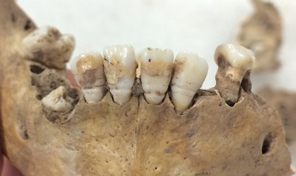

Figure 5. Anterior view of the mandible showing dental pathology

When examining the teeth, there appears to be a yellowish brown mineral on the enamel as well as some transverse lines/grooves across the bottom of the teeth. The yellowish brown minerals are most likely a buildup of calculus on the anterior permanent central and lateral incisors which can also be found on some of the other dentition. In addition to this, it seems to be the case that some of the alveolar bone around the roots of the teeth has deteriorated, leaving some of the roots partially exposed. This could be a sign of periodontal disease in which some of these characteristics are common (Hillson, 2007). Also, some of the teeth have extensive occlusal wear such as the upper right and left first and second deciduous molars.

Other than the dentition of the maxillary bones and mandible, I could not find any other possible signs of pathology when examining this individual. Although there was a lot of porosity in the vertebrae and segments of the sacrum, I believe it is just a matter of growth as opposed to a arthropathy. The superior surface on all the bodies of the vertebra look relatively normal and there are no signs of spinal osteophytes that is characteristic of a degenerative disc disease. Most of the porosity found on the anterior sides of the vertebrae and sacrum is just the exposure of trabecular bone due to physical changes that occurred postmortem. This is most likely because the parts of the skeleton that have higher amounts of trabecular bone are more susceptible to destruction such as the ribs, sternum, and vertebrae.

**Appendix 1**

References

<https://my.clevelandclinic.org/health/articles/11179-teeth-eruption-timetable>

https://www.nature.com/articles/s41598-017-01745-w

(<http://booksite.elsevier.com/samplechapters/9780121028213/9780121028213.PDF>)

AlQahtani, S.

(<http://booksite.elsevier.com/samplechapters/9780121028213/9780121028213.PDF>)